 | EUROPEAN COMMISSION  DIRECTORATE-GENERAL  INFORMATICS  Information Systems Directorate

European Commission
CIPADMIN Use Case Specification:
UC0100 - Authenticate and Authorize User

Date: | 20/01/201715/09/2014
Version: | 20.000001
Authors: | Anamaria BATRINU
Revised by: | Sandro D'ORAZIO, Olivier DERVEAU, Maarten DANIELS
Approved by:
Public:
Reference Number:
TABLE OF CONTENTS
1. Use-Case Description 5
1.1. Primary Actor 5
1.2. Definitions, Acronyms and Abbreviations 5
1.3. References 5
1.4. Overview 6
1.4.1. CIPAdmin Context Diagram 6
1.4.2. Authenticate User Activity Diagram 7
2. Flow of events 8
2.1. Basic Flow 8
2.1.1. User request CIPAdmin resource 8
2.1.2. System verifies if user is authenticated 8
2.1.3. User is authenticated 8
2.1.4. User is authorized, system loads the requested resource (from the caller Use Case) 8
2.1.5. The basic flow ends. 8
2.2. Subflows 8
2.2.1. S1. Authenticate CIPAdmin User 8
2.2.2. S2. Authenticate ECAS User 8
2.2.3. S3. Authorize User 8
2.3. Alternative Flows 9
2.3.1. A1. At step 2.1.2, User is not authenticated 9
2.4. Exceptional Flows 9
2.4.1. E1. At step 2.1.3, User is not authorized 9
2.4.2. E2. At step 3 of subflow S1, CIPAdmin authentication fails 9
2.4.3. E3. At step 3 of subflow S2, ECAS authentication fails 9
2.4.4. E4. At step 1 of subflow S3, user does not exist in CIPAdmin 9
2.4.5. E5. At step 2.1.4., System does not find the requested resource 10
3. Special Requirements 10
3.1. Interface(s) with other Systems 10
3.2. Security Requirements 10
3.3. Other Special Requirement 10
4. Preconditions 10
5. Post conditions 10
6. Additional Information 10
6.1. Includes 10
6.2. Extends 10
6.3. User Access Rights 10
7. Mock-up screens 12
7.1. "CIPAdmin Login" form 12
7.1.1. Login page 12
7.1.2. Login page – required fields 12
7.1.3. CIPAdmin authentication error 13
7.2. CIPAdmin authorization error 13
7.2.1. For non-existing users coming via ECAS 13
7.2.2. For existing users coming via ECAS or CIPAdmin open source version 14
7.3. CIPAdmin Resource Not Found error 15

Document History

Version | Date | Comment | Modified Pages
0.001 | 15/09/2014 | First draft | All
1.000 | 03/12/2014 | CIPADMIN-267 (support role)
1.001 | 11/12/2014 | Added access rights details for CIPADMIN-210 Manage Metadata | Section 6.3 User Access Rights
1.002 | 26/02/2015 | Added access rights details for CIPADMIN-317 Manage Endpoint Configurations for Message Routing | Section 6.3 User Access Rights
1.003 | 27/03/2015 | Added acces rights for Messages (CIPADMIN-257) | Section 6.3 User Access Rights
1.004 | 03/06/2015 | Added access rights for Party Agreements (CIPADMIN-200) | Section 6.3 User Access Rights
1.005 | 08/06/2016 | Added access rights for Resubmit and Redispatch Message actions to ADM role | Section 6.3 User Access Rights
1.006 | 12/09/2016 | Added access rights for Retention and SLA policy  (JIRA ETRUSTEX-1616) | Section 6.3 User Access Rights
2.000 | 20/01/2017 | ETRUSTEX-1937: Reorganizing CIPAdmin user roles

Use-Case Description
This use case describes how a user can connect to CIPAdmin application and how she/he is authorized for the requested resource. The authentication process depends on the version of the application used: for the opensource version of the application the authentication shall be done via a web form, while for the internal commission version the authentication shall be done via ECAS.
This is use case is included in all CIPAdmin Use Cases.
In the remainder of the document the CIPAdmin application will be referred to as the System.

Primary Actor
A User wanting to access the application can trigger the Authenticate and Authorise User use case.

Definitions, Acronyms and Abbreviations
Acronym, Abbreviation or Definition | Explanation
CIPA | Common Infrastructure for Public Administrations
CIPADMIN | CIPA AdminConsole
ADM | A user having General Administrator role. The General Administrator is the Administrator of the CIPAdmin application. ADM can do everything a Central Business Owner can do, plus complete user configuration, profile, document, role, transaction and domain management.
CBO | A user having Central Business Owner role. The Central Business Owner is responsible for the organization and operation of a business and uses CIPA in his business context.
UC(s) | Use Case(s)
ECAS | European Commission Authentication Service

References
Ref. | Reference | Title / description | Version | Date
[R1] | CIPADMIN-VISION | CIPADMIN Vision document | V.61-EN | 18/04/2013
[R2] | ECAS documentation | https://webgate.ec.europa.eu/CITnet/confluence/display/IAM/ECAS | V.48 | 19/08/2013

Overview

CIPAdmin Context Diagram
The diagram below depicts all the Services available on the CIPA Administration Console for e-TrustEx platform. Depending on the user role, only a subset of those services is exposed on the e-TrustEx Administration Console home page.
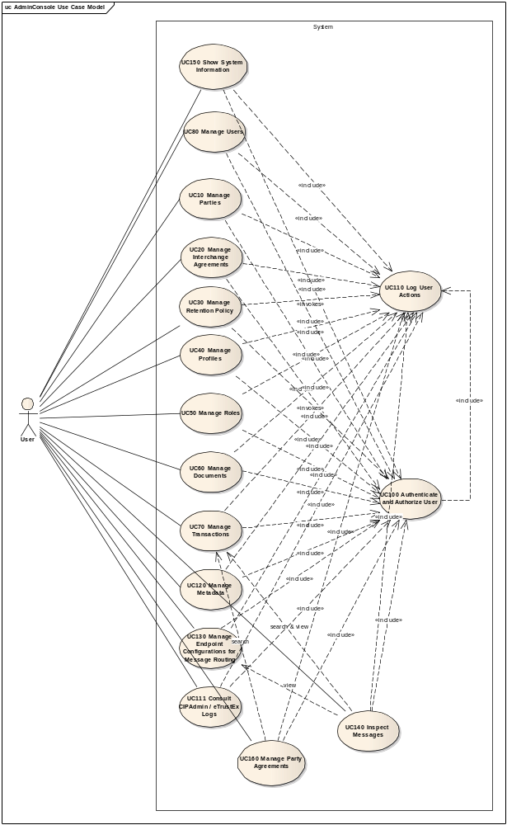

Authenticate User Activity Diagram
The diagram below depicts the set of activities needed in order to authenticate a user to CIPAdmin and the produced outcome.
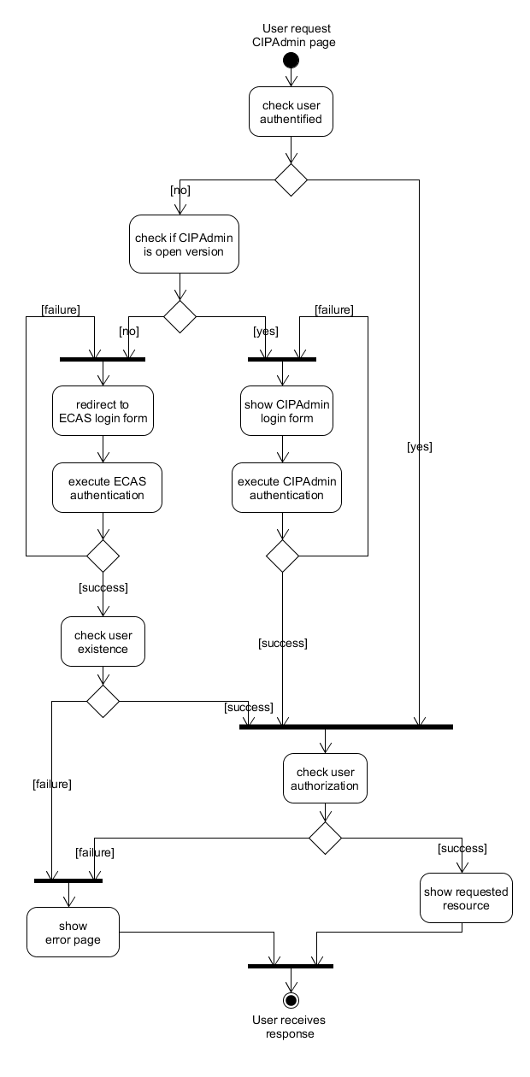

Flow of events

Basic Flow

User request CIPAdmin resource

System verifies if user is authenticated

User is authenticated
- Include UC 0110 – eTrustEx Admin Console – Log CIPAdmin User Actions for successful Login operation
- System verifies if user is authorized for the requested resource by performing subflow S3

User is authorized, system loads the requested resource (from the caller Use Case)

The basic flow ends.

Subflows

S1. Authenticate CIPAdmin User
- System shows CIPAdmin login form (can also contain messages for the user) as described in section 7.1. CIPAdmin Login form
- User fills in the requested information:
  - username - mandatory
  - password - mandatory
- If missing mandatory fields, system restarts at step (1)
- System performs authentication

S2. Authenticate ECAS User
- System shows ECAS login form (can also contain messages for the user)
- User fills in the requested information
- ECAS performs authentication
- User authenticated, ECAS redirects to System

S3. Authorize User
- If CIPAdmin is not open version, system checks if user exists at application level
- System reads the user access rights and verifies the requested resource against them

Alternative Flows

A1. At step 2.1.2, User is not authenticated
- System checks if CIPAdmin is open version
- CIPAdmin is open version, system executes subflow S1
CIPAdmin is not open version, system executes subflow S2
- Alternative flow ends and basic flow continues from step 2.1.3.

Exceptional Flows

E1. At step 2.1.3, User is not authorized
- Include UC 0110 – eTrustEx Admin Console – Log CIPAdmin User Actions for unauthorized Access operation. See section 6.3 User Access Rights for user role authorisation details.
- System displays an error page (as illustrated in section 7.2.2. For existing users coming via ECAS or CIPAdmin open source version) containing an authorization error message and the CIPAdmin email contact to use for further assistance:
"You are not authorized to access this resource. To request new access rights, please contact our CIPAdmin support team at DIGIT-CIPA-SUPPORT@ec.europa.eu"
- Corresponding flow ends.

E2. At step 3 of subflow S1, CIPAdmin authentication fails
- Include UC 0110 – eTrustEx Admin Console – Log CIPAdmin User Actions for unsuccessful Login operation
- System restarts at step 1 of subflow S1, providing the error message to the user.

E3. At step 3 of subflow S2, ECAS authentication fails
- System restarts at step 1 of subflow S2, providing the error message to the user.
Note: This case pertains to an external system (the ECAS System), but it is mentioned here for the sake of completeness.

E4. At step 1 of subflow S3, user does not exist in CIPAdmin
- Include UC 0110 – eTrustEx Admin Console – Log CIPAdmin User Actions for unauthorized Access operation
- System displays an error page (like illustrated in section 7.2.1. For non-existing users coming via ECAS) containing an authorization error message and the CIPAdmin email contact to use for further assistance:
"You are not authorized to access this application. To request application access rights, please contact our CIPAdmin support team at DIGIT-CIPA-SUPPORT@ec.europa.eu by providing the following information:
- request reason (mandatory)
- username (mandatory)
- business domain (mandatory)
- user role (mandatory)
- party (optional)"
- Corresponding flow ends.

E5. At step 2.1.4., System does not find the requested resource
- Include UC 0110 – eTrustEx Admin Console – Log CIPAdmin User Actions for unsuccessful Access operation
- System displays an error page (like illustrated in section 7.3. CIPAdmin Resource Not Found error) containing an error message and the CIPAdmin email contact to use for further assistance:
"Resource not found. If error persists, please contact our CIPAdmin support team at DIGIT-CIPA-SUPPORT@ec.europa.eu and provide all relevant information."
- Corresponding flow ends.

Special Requirements

Interface(s) with other Systems
It uses ECAS authentication service for authenticating users, when the version used is not the opensource version.

Security Requirements
On top of the authentication and authorization services provided by CIPAdmin, the application server shall contain an extra layer of security for preventing any intrusion attempt.

Other Special Requirement

Preconditions

Post conditions
- [Success] The User access the requested resource.
- [Failure] The use case is aborted and the primary actor has been notified of the reasons.

Additional Information

Includes

Extends

User Access Rights
The table below contains a summary describing what modules can be accessed by a user having a given role, and what operation can be performed per module in the context of a given business domain.
User role | Module | Operation | Related condition
ADM | All (exceptions below) | All | N/A
ADM | User | All | N/A
ADM | User | Change Password | Opensource version only (for him/herself)
ADM | Messages | Search | N/A
ADM | Messages | View
ADM | Messages | Resubmit
ADM | Messages | Redispatch
ADM | Logs | Search | N/A
ADM | Logs | View
ADM | System Information | View | N/A
CBO | Party | All | Business domain related
CBO | Interchange Agreement | All | Business domain related
CBO | Certificate (via Party) | All | Business domain related
CBO | User | All | Business domain related
CBO | User | Change Password | Opensource version only (for him/herself)
CBO | Party Agreement | All | Business domain related
CBO | System Information | View | N/A
 | Routing Endpoints | All | Business domain related
 | Transaction (only in the context of Routing Endpoints) | Search  View | Business domain related
 | Retention Policy | All | Business domain related
 | Messages | Search  View  Resubmit – No access  Redispatch – No access | Business domain related
 | Logs (eTrustEx/CIPAdmin) | Search  View | Business domain related

Mock-up screens

"CIPAdmin Login" form

Login page
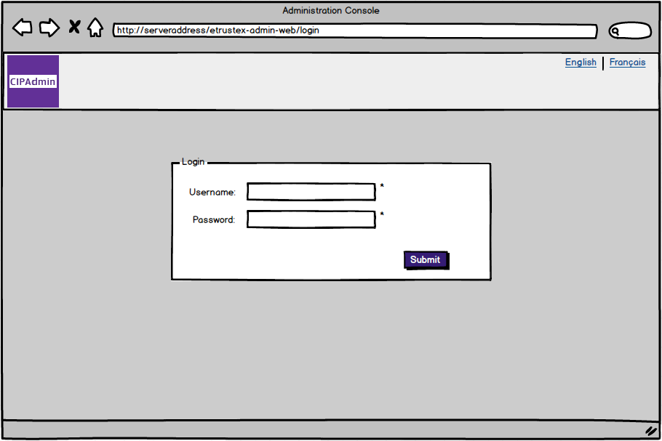

Login page – required fields
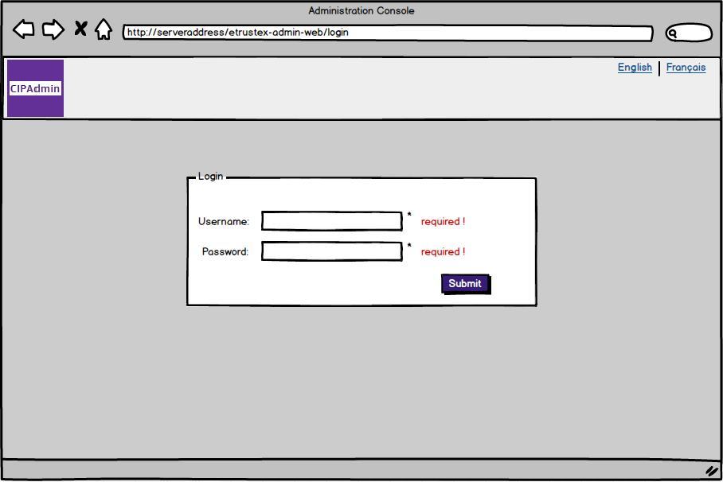

CIPAdmin authentication error
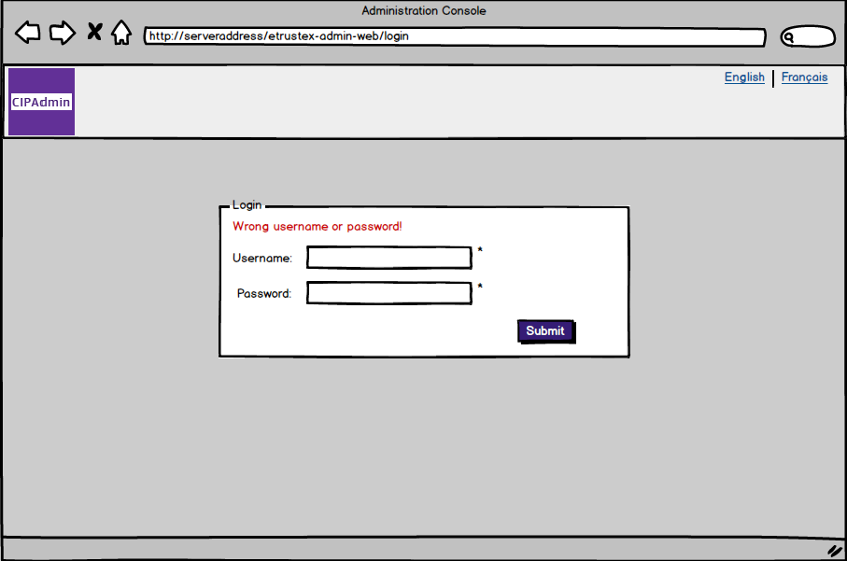

CIPAdmin authorization error

For non-existing users coming via ECAS
Note that in this case the error page is the only resource accessible by a non-existing user, and the only action he/she can take is to contact the support team for help.
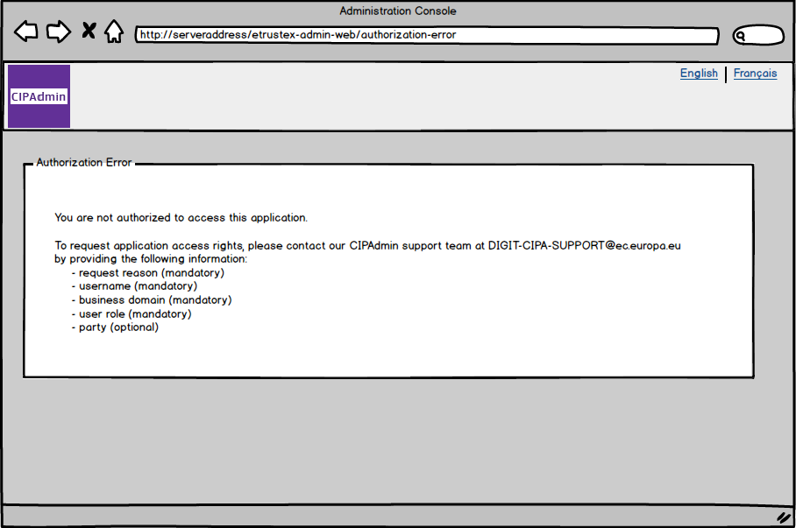

For existing users coming via ECAS or CIPAdmin open source version
Eg. A user having LBO role and trying to access the document module will get this error. Even if it is not in the menu the document module could be accessed by typing the correct address in the browser window (like " http://serverAdress:serverPort/etrustex-admin-web/document/new.do").
Note that in this case the user is not blocked, the menu remains accessible and user can continue using the application.
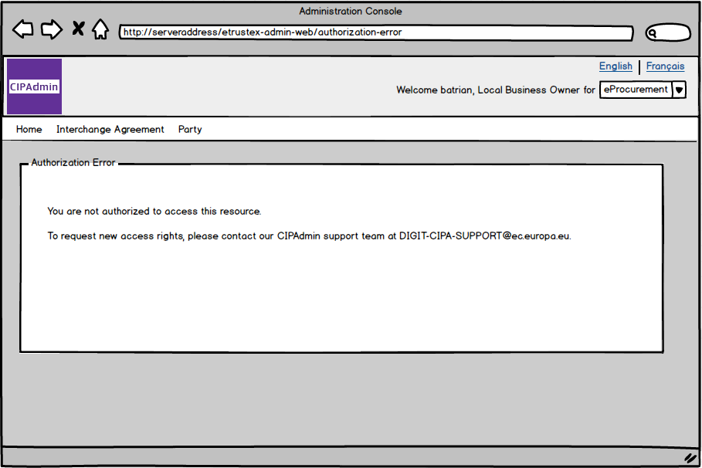

CIPAdmin Resource Not Found error
